Spelling in the Classroom
Idea Bank
Created by Erin Schreiner
Updated materials by Andy Flaherty 9/5/2018

NOTE: Updates will be posted (Starting September 15th) regularly along with the poster, registration information, and day of event details at http://english.conceptschools.org/spelling-bee/.

Spelling Bee Games

Perhaps it is the success of online, phone Apps like words with friends, but words involving games are very popular with young and old. There are a number of free sites and also sites where you could obtain a free 30 day trial, but you can also check out these two free websites (Spelling Bee and Word Game Time):

- https://spelling-bee.com/?fca=1&success=0#/

- http://www.wordgametime.com/about-us.html

Make these games extra credit assignments or use as a partner activity at the end of a period once every other week.

Spelling Bee Poster Competition

Set up a competition to have students design posters. Teachers engage all students in a lesson that presents effective poster designs and the elements that students should include in their individual event posters. Students create posters that reflect the theme of the Spelling Bee: Spellbound. Posters are then judged by a panel that includes students. The winning poster is replicated and posted throughout the building to announce the school-wide Bee.
Offer prizes for best poster and possibly a runner up. This is a great way to involve all students not just those in the competition.
Posters might include:

- Date, Time, and Location
- Connection to Spelling Bee Theme
- Graphic element like drawings or photographs

Spelling Bee Themed Books

Teachers and students work together to create a library of spelling bee themed books that students can select from for individual reading or as a class, perhaps offering them extra credit for reading and reporting on these books. Often, once students see spelling bees represented in books they take more of an interest in the prospect of the bee.

Possible books include:

I Put a Spell on You by Adam Selzer
Spelldown by Karon Luddy
The Berenstain Bears and The Big Spelling Bee by Stan and Jan Berenstain
Pinky and Rex and the Spelling Bee by James Howe
The Spelling Bee by Brent Davis

Friday Bees

Add weekly competitions to your class by holding a mini spelling bee each Friday at the conclusion of the day’s lessons. Direct all students to stand next to their desks moving up and down the rows as they spell a word correctly. Ask the students to sit once they get a word incorrect. Knowing that they will have to sit back down makes many of them put a bit more effort into their spelling as standing is -- oddly -- a treat.
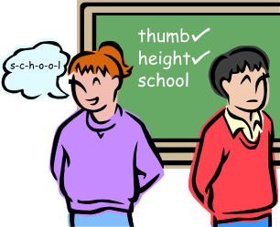

Spelling Bee Journals

Students do informal writing in their journals about spelling bees and spelling-based themes, perhaps connecting entries to the spelling- themed books by creating reading journal entries. In addition, you might have them focus on designing a hypothetical spelling bee trophy. Ask each student to imagine the most awesome spelling bee trophy he/she can. Instruct the students to write 4-6 sentences describing in EXCEPTIONAL detail what the trophy would look and feel like (they can even include smell if the trophy is made of something particularly aromatic).

After students have written this, allow them to draw their trophies or create mini-models of their trophies, perhaps offering them bonus points for doing so. Extend writing about spelling bees into pre-writing on the need for spelling bees (or not), profiles on the type of students who compete, etc.
Spelling Poems

Create a class poetry book about spelling bees. After reading up on spelling bees or perhaps watching a movie like “Akeelah and the Bee,” teachers ask students to write poems about spelling bees. To assist them in doing this, brainstorm words that could be associated with spelling bees, including words that would describe how competitors may feel while participating. Divide students into pairs and give each pair a different poetic form (assigning Haiku to one group, Cinquain to another, etc.). Ask each group to compose a spelling-bee centric poem using the brainstormed words as tools following the assigned form. Have the finished book bound and place it in your classroom library. Tip – To differentiate, deliberately assign easier poetic forms to students who struggle more and harder forms to students who naturally write well.

Spelling Bee Skits

As a continuation of a drama mini-unit or at the conclusion of reading a play, teachers divide students into groups and ask them to compose skits in which they depict individuals engaging in a spelling bee. Allow students to act out their skits. For older students, you might make this more challenging by putting different genre-words in a hat and having them randomly select a category in which their skits must fit (for example, the hat could include mystery or science fiction, etc

Spelling Bee Movies

Broadway’s done it with their show The 25th Annual Putnam Country Spelling Bee which is a show centered on a fictional spelling bee set in a geographically ambiguous Putnam Valley Middle School. Six quirky adolescents compete in the Bee, run by three equally quirky grown-ups.

There are also many films that use the setting of a spelling bee to tell a story. You might consider rewarding students with a showing of a film if they do exceptionally well preparing for your local bee. Here are a few films: Akeelah and the Bee, Spellbound, Bee Season, Spelling Bee, Bee Nation, and a Boy Named Charlie Brown.

News Miss-Spellings
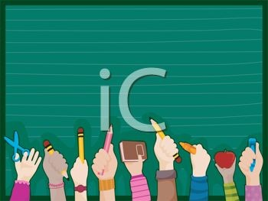

Identify examples of how spelling impacts the world around us. Teachers provide mini-lessons on examples from newspapers, magazines, and billboards with miss-spellings. Engage students in discussions that demonstrate the dangers and humor when these errors occur. Then encourage students to seek out examples of their own from the “real world.” Have students bring them in and write an explanation of how the error could lead to problems, etc. Feature a bulletin board in your room of these examples from real life with student explanations.
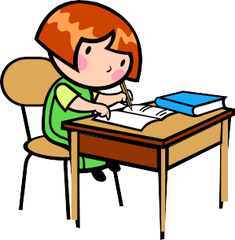

Spelling Bee News

Create newspaper articles about the Spelling Bee. Using the initial pre-writing from their journals, students begin to learn about journalism and how stories are covered. Teachers instruct students on the basics of writing a feature story and then have them write stories about your local Spelling Bees. Also, have students write profiles on various competitors in the spelling bee. Perhaps what they write could be used for your Spelling Bee program or an existing school newspaper. If not, you could post student articles and profiles in the hallway. Once posted have, have students read and report on a story they liked and/or found interesting.

Spelling Bee Song and Dance

Try thinking outside the box with creating songs and dances to support your spelling efforts. Many of our students like Flocabulary that uses music to teacher various skills. Why not make a competition to develop a school song, or dance, to represent your school’s efforts? Here are a few ideas to get you started:

- https://www.youtube.com/watch?v=eh8FSo6eLoU

- https://www.youtube.com/watch?v=J7luckYbILs

- https://consequenceofsound.net/2017/03/spelling-bee-the-10-best-songs-with-spelled-out-words/

