Concept English- Flaherty
Mimetic Writing
PD Workshop – 1.5 Hours

Teaching writing is hard. But consider having students mimic, imitate, other authors to help them enter the the writing realm. Research from National Writing Project says it works. My experience, too, has proven it builds fluency and helps students connect with the craft of writing. It is also a great way to read for details and synthesize words and ideas into writing forms.

Let’s consider a poem by Sandra Cisneros.

Abuelito Who

Abuelito who throws coins like rain
and asks who loves him
who is dough and feathers
who is a watch and a glass of water
whose hair is made of fur
is too sad to come downstairs today
who tells me in Spanish you are my diamond
who tells me in English you are my sky
whose little eyes are string
can’t come out to play
sleeps in his little room all night and day
who used to laugh like the letter k
is sick
is a doorknob tied to a sour stick
is tired shut the door
doesn’t live here anymore
is hiding underneath the bed
who talks to me inside my head
is blankets spoons and big brown shoes
who snores up and down and up and down again
is the rain on the roof that falls like coins
asking who loves him
who loves him who?

QUESTIONS:
How will you read it?
How would you unpack the imagery?
How does the imagery give you clues about her relationship with her grandfather?
What is the standard you are teaching?
How will you know it is mastered?

NOTE: Images show us instead of telling us.
Consider another poem using this form (perhaps yours). Here is my version.

Grandma who throws Lefsa like Frisbees
and asks who loves her
who is jelly and peanut butter
who is an agate key chain and cup of coffee
whose hair is made hay
is too happy to stop laughing today
who tells me in Norwegian you are my treasure
who tells me in English you are my loyal grandchild
whose brown eyes are chocolate peanut butter balls
can come out to play
after the chores and animals are fed
who used to cry like the s
is healthy
is a wind chime hanging from a nearby tree
is rested opens the door
doesn’t seem so sad anymore
is ironing sheets next to the bed
who talks to me inside my head
who tends chickens chores and apron strings
is the Frisbee in the air that spins across her hands like Lefsa
asking who loves her
who loves her who?

QUESTIONS:
How are these poems similar and different?
How will students SEE this comparison?
What standards are you teaching?

STEPS FOR MIMETIC WRITING:

- Chose Cisneros and/or your model and underline with students the first word or words of each line.
- Students select a person they care deeply about.
- Students brainstorm a list of personality traits, characteristics, as well as interests, physical features, and phrases that are unique to their chosen person.
- Then use key aspects of the form (observed in the compare/contrast above) to use as a template.
- Have students partner, exchange poems, and read aloud. Give guidelines or questions for talking about the writing.
- Have students revise based on conversation.
- Author’s chair.

QUESTIONS:
What skills/standards does this mimetic address?

Connecting to content reading/writing
For example, consider 7th grade Unit 1 Collections – Bold Actions, and you are currently reading mythology. You have chosen a piece on Achilles and you want to check the reading of facts and the use of textual evidence.

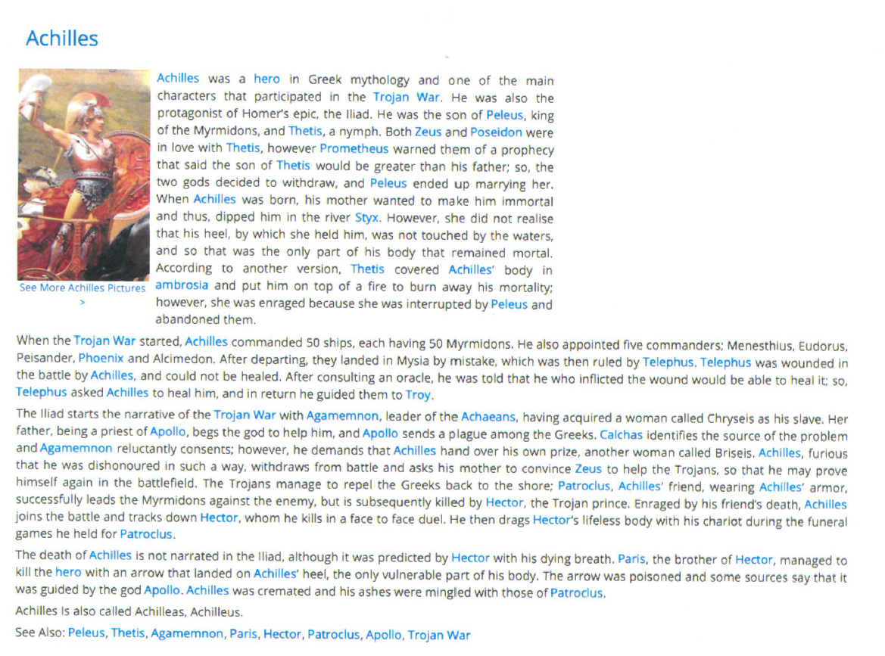
instead of simply asking questions, engage students in the use of the information they have just read.

STEPS FOR WRITING ABOUT THE TEXT:
- Recall/review your writing of poems using the Cisneros template.
- Re-read the pieces about Achilles and highlight key personality traits that you think are important in showing us who he is.
- Using these details, you may do the exact same thing we did for our poems about a person we care about or, you may use some aspects of it.
- Write a poem about Achilles.

QUESTIONS:
What standards does this address (reading and writing)?

Achilles Who?

Achilles you run and run like a river
Never remembering to embrace your pain
You are strength and weakness
The arrow to the bow entwined.
Achilles your face is stone
Your body sculpted like marble
But your cord weak
Where your mother Thetis
The sea nymph
Dipped you in the River Styx.
Achilles your armor cannot hold
What your mother held
Your Achilles heal will surrender you.
If only you had looked beyond
You might have seen the gift
The paradox of weakness living
Inside your chest like the
Men hidden in the Trojan horse
Ah, Achilles
What a gift
You have given me.

QUESTIONS:
Can you connect more directly to the writing goals of the unit?
Can you attach the next writing to a specific prose goal?

Consider turning poetry into prose.

Achilles was a hero in Greek mythology and clear a character capable of Bold Actions. He was fast and ran like a river, always appearing to escape pain. But he had both strength and weakness. The crux of the problem had to do with what happened to him when he was little. When his mother, Thetis, dipped him in the River Styx, she grabbed his heel. It is that spot, his Achilles heal, that was his weakest. In fact, today we refer to someone’s Achilles heel as their weak spot. The moral of the story is often articulated as the need to identify your weakness and prepare for them because they may keep you from harm. The paradox of strength and boldness is that we all are weak.

QUESTIONS:
What steps would you write to take the poem to the prose version?

Here is a link to a creative writing blog for adults that explains the power of Mimetic Writing
https://www.circeinstitute.org/blog/what-mimetic-teaching-lost-tools-writing-excerpt

