Writing Competition 2020
Guidelines

Theme: You Find Your Truth Within
Sometimes words hidden in plain sight give us insights

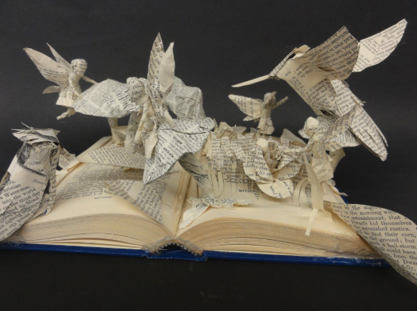

This year, all students will create a Found Poem following the specific grade level requirements. Yes, if students participated in the Spoken Word event they may revise poem, following the guidelines below, and submit. Teachers may submit up to 5 poems from each class; poems that demonstrate evidence of the writing process. In other words, the best of the best.

Here is how you create a found poem:

- Review multiple texts (newspapers, books, billboards, flyers, etc.) and record 10, or more words, phrases, or quotations that are meaningful to you (see attached form).

- Identify a central idea, theme, or topic from what you have gathered that will be the focus of your found poem.

- Select words, phrases, or quotes that reflect the theme you wish to comment on. For example, you may be thinking about loyalty or truth and then you decide on truth so you only select text that reflects that support your thinking about truth.

- Draft your poem by writing words, phrases, and quotes out on strips of paper so you can move them around and experiment with meaning. You may repeat words or phrases as often as you like. Once you have them organized you must use your own words to glue everything together for a clear message.

- Grades 3-5, poems must be 5 -10 lines minimum
- Grades 6-8, poems must be 10-15 lines minimum
- Grades 9-12, poems must be 15 or more lines

- After you type the poem, you must add a poet’s statement. This statement will explain your poem by answering 3 questions: 1) What connection did you find within the words and the thinking in your head? 2) What evidence can be found in your poem that supports the answer to question one? 3) How is the message in your poem an example of your truth? This should be a minimum of 5 well written sentences with appropriate punctuation.

- Your submission must include the following:

  - Title, Student Name, School, Grade Level
  - Written in Times New Roman (no larger than 14pt)
  - Submitted in word, no PDF’s accepted

Deadlines/Prizes

Teachers select up to five students from each class for submission. Entries must be received at aflaherty@conceptschools.org in word format, including a poet’s statement, and appropriate headings no later than March 27, 2020.

A winner for each level/grade band:

3 - 1st place winners $100
3 – 2nd place winners $75
3 – 3rd place winners $50
3 – Honorable mention $25

