Concept English Unit/Lesson Plans
Suggestions for Improvement

Unit plan Masters are provided to each Concept English teacher with the expectation that she/he will customize them to fit their specific school culture and student’s needs. This means we must subtract/add to the unit first before we teach it. The master has been copied into our teacher accounts. We must then modify it to fit our approach as well as the needs of our students. Before we begin to put in our lessons, we must revise (simple type into boxes) our unit overview, essential questions, and delete or add standards as necessary.

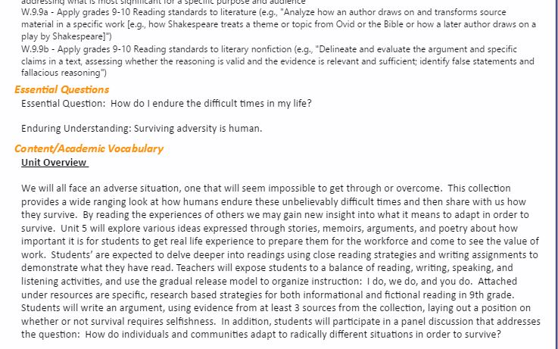

We must also look at the readings beyond the Anchor Texts, which are essential, and delete what we will not use from the Collections list as well as the readings listed as Other. If we add readings, they must be listed under Other and attached under resources. NOTE: If we use our own strategies, assessments, etc. they must be labeled and attached to the unit/lesson. A PDF (1/3)of Unit 5 is attached with questions in each section to help us revise. Note: Master Units exist under my name should you ever need to go back and get something you have amended/deleted.

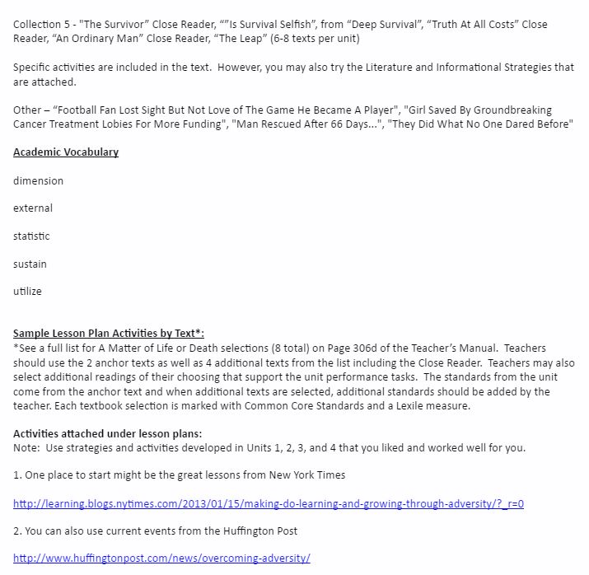

Carefully designed lesson plans are essential to clear, organized, and engaging lessons. Nearly 93% of all districts in the United States require us to do them. They include the following elements:

- A link to past learning that draws students into new learning
- Have practice with the teacher, with peers, and independently
- Ongoing checks for understanding
- Adjustments to meet the needs of diverse learners
- Closure that ties all lesson phases together
- Timing that maintains interest and engagement throughout the lesson

Lesson plans are not little snippets here and there to get you through the day. They are linked day to day, week to week, throughout the year to the larger unit structure. We do not teach author’s purpose today and then set it aside, never to be reviewed or practiced again. Teaching and lesson plans reflect a continuing process that when placed together create a larger product—a unit of integrated study (6 per grade level) following a scope and sequence. Daily lesson plans are linked by concepts to our unit plans and become proof of our professionalism.

The following chart reflect the many different words used by professionals to refer to the sections of our lesson plans. A closer review suggests they are all asking for basically the same thing:

Teaching as Leadership | ASCD | Madeline Hunter | Other | Concept English
Introduction | Phase 1, 2, 3 (Intro, Foundation, Brain Activation) | Anticipatory Set/Purpose/Input | State Standard | Before/Bell Ringer
Lesson Body | Phase 4, 5, 6 (New Info, Clarification, Practice & Review) | Modeling/Guided Practice/Checking for Understanding/  Independent Practice | Procedure | During/Steps
Assessment | Phase 7, 8 (Independent Practice, Closure) | Closure/Output | Assessment | After/Exit Slip

The majority of your lesson plans have a before section with a bell ringer listed and standards stated. Most of our Concept English lessons also have an after – an exit slip or short assessment to measure learning. Where we need our greatest improvement is in what Concept English refers to as the “During” section. This is where the process or procedure for our day is made very clear. We have often talked about the I Do, We Do, and You Do of the lesson. The I Do (teacher part) is clear but “what the students will do during the lesson,” is still too vague.

When I plan I ask myself: What do students need? (inputs); What should students learn? (output); What will I do as teacher?; What will the students be doing during the lesson?; and, how will I know they learned? If I add the detail using Bloom’s verbs for the During section, we can see what the students are DOING!

Sample Lesson Plan
English I, 9th grade, Unit 5 – A Matter of Life or Death

Anchor Text – Excerpts of Night, poem The End and The Beginning

Day 1 Lesson Plans (Friday, March 18)

Materials: Handouts referenced are all attached as PDF’s (2/3)here and in SIS

Before
Bell ringer/Journal: When facing a difficult situation or problem, how can working with another person help you or hurt you? Explain. Your answer must be 5 to 7 complete sentences.

I can read and discuss orally
I can define and use reciprocal teaching strategy
I can work collaboratively

(While the I can’s are listed in the Unit, putting specific ones into our lessons can help us focus)
During
- Explain and outline four reciprocal teaching strategies on the board: summarizing, clarifying, questioning, and predicting. Students copy outline into notes.
- Students provide explanations for each. Record student comments on board. Develop classroom definitions that students write into their notes.
- Explain how students will apply these strategies (4) while reading Night.
- Using interview of Wiesel with Oprah (print or video) lead classroom discussion applying/modeling the strategy so that student become familiar with process to be used for Night.
- Students summarize information in notes. Share out
- Students list words or ideas in notes. Share out
- Students prepare questions that touch on fact, interpretations, and deeper issues
- Students predict what will come in Night. Share as whole class, list on board.
- Pass out the Reciprocal Teaching Guidelines. Compare and Contrast the guidelines with the definitions created and posted by class.
- Pass out the Discussion Question Guidelines and review/summarize the three types of questions.
- Students write down given examples and non-examples of these types of questions.
- Pass out copies of the Reciprocal Teaching Notes and ask students to use the format to classify the information the read for homework or next day in class reading the Preface and Forward to Night.

After
Exit Slip: Working with a partner students create one or two questions based on the discussion guidelines that they have about the interview with Mr. Wiesel.

Key: Green words are Bloom’s Taxonomy action verbs and a PDF (3/3) is attached.

Note: I keep a word document on my computer with this format so that I can simply go in and amend it. I can then cut and paste it directly into SIS.

