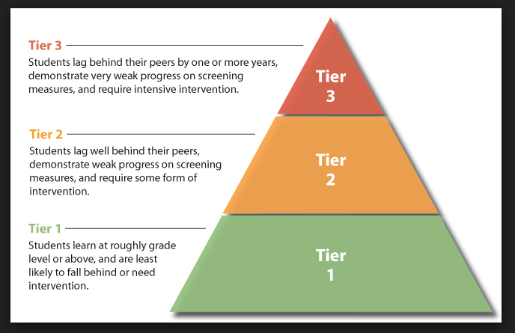

# 3 Tiers

**Each of Concept’s 33 schools throughout 7 states will have their own specific RtI plans to address the needs of its student population. Classroom teachers gather information about student - skills and behaviors - then work with grade-level teams to develop a complete RtI plan.**

**Andy Flaherty**

847.824.3380 Ext: 210

Director of English Education

[aflaherty@conceptschools.org](mailto:aflaherty@conceptschools.org)

For More Information Call

🙞 🙜

#### Response to Intervention is the practice of providing high quality instruction and interventions matched to student’s needs.

Internet Website Resources

www.rti4success.org

www.interventioncentral.org

www.rtinetwork.org

www.pbis.org

www.calmclassroom.org

www.safeandcivilschools.org

**Concept Schools’**

Parent Guide

### 2250 E. Devon Avenue Suite 215

### Des Plaines, IL 60018

🙞 🙜

## Praesent mattis massa non nisi.

Response to Intervention

RtI

## Q & A

**How Can I Get Involved in RtI As A Parent?**

Ask important questions:

* Does this mean my child is special Ed?
* What types of programs and interventions will my child receive?
* How will I know if my child is making progress?
* What can I do to help my child?
* What will the school do if my child is not improving?

What Do I Do If I Believe My Child Is Struggling?

* Talk with your child’s teacher
* Review and check homework
* Celebrate your child’s success
* Learn about curriculum

For more information on what parents can do visit:

http://www.ncld.org/learning-disability-resources/ebooks-guides-toolkits/parent-guide-response-intervention

“Response to Intervention (RtI) is an approach for redesigning and establishing teaching and learned environments that are effective, efficient, relevant, and durable for all students, families, and educators. RtI involves an education process that matches instructional intervention strategies and supports to student needs in an informed, ongoing approach for planning, implementing and evaluating the effectiveness of instruction, curricular supports, and interventions. The approach has 3 tiers. See the image above for further explanation.

RtI is also a process designed to help schools focus on and provide high-quality instruction and interventions to students who may be struggling with learning.

An intervention is a specific type of instruction that is used to help with a specific problem. Interventions are matched to student needs. Student progress is monitored often to check the effectiveness of the instruction and interventions. The data collected on a students’ progress are used to shape instruction and make educational decisions. Use of RtI process can help avoid a “wait to fail” situation because students get help promptly with the general educational environment. “

# RtI and the 3 Tiers

# About RtI