Response to Intervention

Concept Schools RtI Folder
Table of Contents

A special thank you is owed to Cheryl Kalkirtz, Director of Special Education, for her research into the law and various resources surrounding RtI that helped facilitate this presentation.

Overview
Definition - What is RtI? Page 4
Framework – Three Tiers Page 5
RtI Flowchart – Interventions Page 6
RtI Glossary – Key terms Page 7, 8, 9

Resources (Version Required with Deadlines)
Form 1 RtI Request Form Page 10
Form 1a Prior Intervention Support Page 11
Form 1b Functional Behavior Support Page 12,13
Form 2 Grade Level Team Checklist Page 14
Form 3 RtI Tracking Form Page 15

Additional Resources
Special Education Recommendations Page 16, 17

Problem-solving is the basis for RtI and is defined as activities designed to “eliminate the difference between “what is” and “what should be” with respect to student development” (Deno, 2002; p. 38). Problem-solving within Tier 2 tends to focus on identifying specific deficits (e.g., fluency vs. comprehension), but analysis within Tier 3 involves collaborative efforts to identify the current level of performance, the desired level of performance, and variables that prevent the student from obtaining that desired level. At the secondary level, problem analysis and development of intervention plans is typically conducted by a team of teachers. Grade-level teams drive the RtI process at the elementary level, but secondary efforts are carried out by different types of teams. Most high schools use a content-area team, such as the English department, to examine universal screening data and to monitor progress with students receiving interventions. Some schools use multidisciplinary teams when the teams exist within small learning communities or “houses.” Tier 3 analyses and problem solving should be conducted by a multidisciplinary team that is trained in the problem-solving process.

Excerpted from the website of the Center for Response to Intervention at American Institutes for Research

What is RtI?
Response-to-Intervention (RtI) is the practice of providing high-quality instruction/intervention matched to student needs. Progress is closely monitored and changes in instruction are based on data collected from on-going assessment. RtI represents an educational strategy to close achievement gaps for all students, by preventing smaller learning problems from becoming insurmountable gaps. (NASDSE, 2006)
What do the tiers mean?
Tier I -ALL students receive Tier I interventions, also known as “Best Practices.” Tier I interventions will be successful with 80-90% of the student population. Classroom teachers provide Tier I interventions and supports.
Tier II- Based on academic school-wide screening, students who are not meeting grade level benchmarks and for whom Tier I interventions are not supportive enough will receive Tier II interventions. They receive the same instruction as students in Tier 1 as well as targeted interventions. Tier II represents 5-10% of the population. Tier II interventions are provided by the classroom teacher as well as support staff when necessary.
Tier III- Students who are not making adequate progress at Tier II will receive Tier III interventions. Tier III interventions include intensive instruction, specific to the student’s highest area(s) of need. Tier III should only represent 1-5% of the population. Tier III interventions are provided by the classroom teachers as well as specialists in the specific area of skill deficit.
Key Terms
Response to Intervention (RtI) - A multi-tiered, problem-solving approach providing services, both prevention and intervention, that address academic and behavior difficulties of all students at increasing levels of intensity.
High Quality Instruction—Children receive instruction that follows a scope and sequence. Instruction is differentiated within the classroom to meet a broad range of student needs.
Research-Based Interventions—The instruction reflects the accumulation of research on how children learn best and how teachers are best able to assist those who are struggling.
Universal Screening—Tools, such as Curriculum Based Measures (CBM) , checklists, or direct assessment, are used to identify levels of proficiency for each student in essential academic and behavioral areas. Those students who are not meeting grade level standards are identified as needing more specialized instruction.
Progress Monitoring— Scientifically based practice that is used to frequently assess students’ performance and evaluate the effectiveness of instruction. Data that indicates a substantial lack of progress signals the need for more intensive interventions that match the skill deficit.
What are the Benefits of RtI?
- RtI ensures a shared approach is used in addressing students’ diverse needs.
- Parents are a very important part of the process.
- RtI eliminates the “wait to fail” situation, because students get help promptly within the general education setting.
- The RtI approach may help reduce the number of students referred for special education services while increasing the number of students who are successful within regular education.
- RtI helps to identify the root cause of achievement problems.
RtI’s use of progress monitoring provides more instructionally relevant information than traditional assessments.

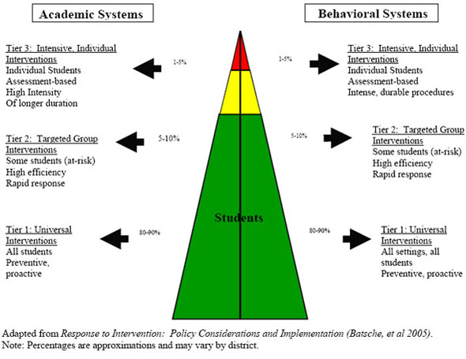

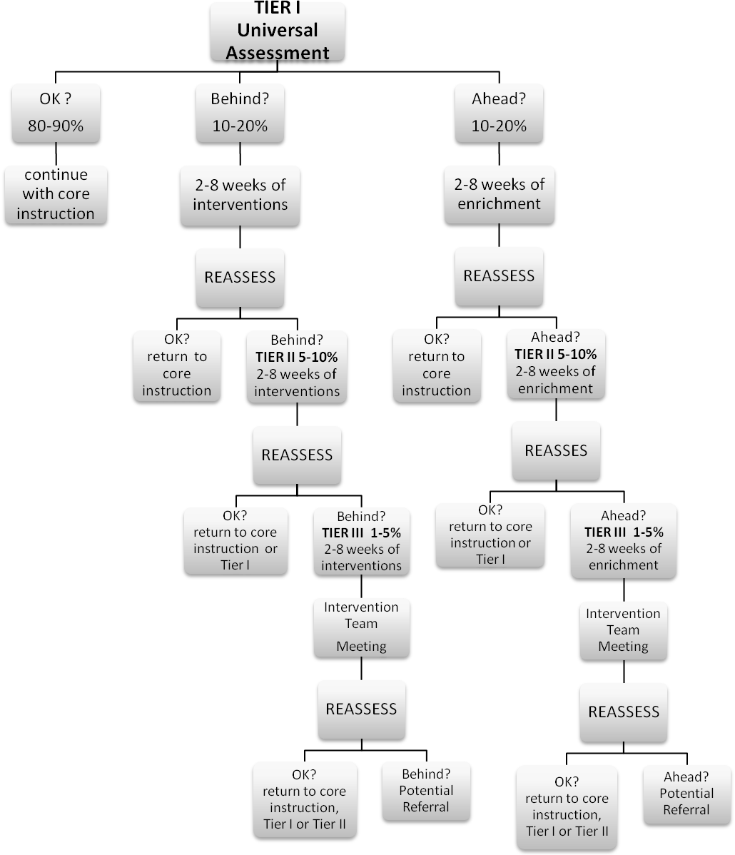

RTI Glossary

(Definitions are based on research. Practice may vary slightly based on the needs of the individual school buildings).

Behavior Intervention Plan A behavior intervention plan is based on a Functional Behavior Assessment (FBA). It is developed and implemented by a collaborative team, which includes the student and parent. The plan includes positive behavior supports (PBS), identified skills for school success, and specific strategies for behavioral instruction.

Data-Driven Decision Making The process of planning for student success (both academic and behavioral) through the use of ongoing progress monitoring and analysis of data.

Discrepancy Statement
A clear and measurable statement of student performance as compared to same-age peer performance. *Behavior example: When observed in circle time, Billy is on-task 30% of the time compared to classmates who are on-task 88% of the time. (Academic example: Jonathan, a fourth grader, is reading 65 correct words per minute (wpm) with 3 errors. His peers are currently reading 95 correct words per minute (wpm) with 3 errors).

Duration How long a behavior or an intervention occurs. Commonly used in Functional Behavioral Analysis (FBA) and Response to Intervention (RtI) in the context of examining and observing the three most important factors of concern: Frequency, Intensity, and Duration.
For the purposes of documenting response to intervention, duration refers to the length (number of minutes) of a session multiplied by the number of sessions per school year. "Sufficient duration" is dependent on a number of factors including the program or strategy being used, the age of the student, and the severity of the problem. Some programs offer guidelines or recommendations for duration.

Evidence-based Instruction/Interventions
See research-based instruction/intervention/practice.

Fidelity Refers to the accuracy, loyalty and attentiveness with which an intended research design for instruction and/or intervention is implemented. To support standardization, intervention specialists must generally follow a prescribed protocol in order to ensure a program or strategy's fidelity.

Flexible Grouping Prescriptive, focused, research-based interventions provided to students by any trained or skilled staff member, regardless of the child's special or general education categorization or the educator's special or general education job description.

Focused Assessment Formal and informal assessment targeted to specifically plan program service delivery and/or appropriate interventions for student success.

Frequency How often a behavior or an intervention occurs. Commonly used in Functional Behavioral Analysis (FBA) and Response to Intervention (RtI) in the context of examining and observing the three most important factors of concern: Frequency, Intensity, and Duration.

Functional Behavior Assessment (FBA) This term comes from what is called a "Functional Assessment" or "Functional Analysis" in the field of applied behavioral analysis. This is the process of determining the cause (or "function") of behavior before developing an intervention or Behavior Intervention Plan (BIP). The intervention/BIP is based on the hypothesized cause (function) of behavior.

Adapted originally from Stephen Starin, Ph.D., http://www.aspennj.org/pdf/information/articles/functional-behavioral-assessment.pdf

Gap Analysis Gap Analysis is a tool for measuring the difference between the student's current level of performance and benchmark expectations.

Hypothesis
A hypothesis is theory about why or why not a behavior is occurring. A discrepancy statement + because = hypothesis. A hypothesis must be written in specific, observable, and measurable terms.
(Example: Beth is on-task for 35% of the time while peers are on-task 87% of the time during a 15-minute observation during circle time, because she is escaping the letter sound activity which is above her instructional level).

Intensity The adjustment of duration, length, and teacher-to-student ratio for a child's academic or behavioral needs.

Intervention The systematic and explicit instruction provided to accelerate growth in an area of identified need. Interventions can be provided by both general and special educators, and are based on training, not titles. They are designed to improve performance relative to a specific, measurable goal. Interventions are based on valid information about current performance, realistic implementation, and include ongoing student progress monitoring.

Latency The length of time it takes to begin a task after the directions are given.

Multi-tiered Model Providing differing levels of intensity [i.e., universal (Tier I), strategic (Tier II), intensive (Tier III)] based upon student responsiveness to intervention, with ongoing progress monitoring and focused assessment.

Prescriptive Intervention Instruction of a specified skill that focuses on academic or behavioral areas of concern to meet the specific needs of a student.

Problem-Solving Process Steps a collaborative team (which includes general and special educators, and at times parents) completes to evaluate student data and to plan and monitor prescribed interventions.

Progress Monitoring The ongoing process of collecting and analyzing data to determine student progress toward specific skills or general outcomes. Progress monitoring generates useful data for making instructional decisions based on review and analysis of student data. Monitoring student progress, through collection and analysis of data, is an effective way to determine if the selected intervention is meeting the needs of the student.
Research-based Instruction/Intervention/Practice An evidence-based instructional practice or intervention found to be effective with a particular group of children. When appropriately used, children can be expected to make adequate gains in achievement. Ongoing documentation and analysis of student outcomes helps to define effective practice.

School wide Positive Behavior Supports (PBS) A school wide, multi-tiered framework designed to develop positive learning behavior in all students. PBS focuses on prevention of inappropriate behavior rather than development of consequences for inappropriate behavior.

Screening Refers to a checklist, observation, survey, or probe about a student's development or skills to see if further evaluation is needed.

Specific, Measurable Outcome The statement describing the single, specific, desired result of an intervention. To be measurable, the outcome should be expressed in observable and quantifiable terms (i.e., Johnny will demonstrate mastery of grade-level basic math calculation skills as measured by a score of 85% or better on the end of the unit test on numerical operations).

Tier One (Universal) Intervention Tier I Interventions are those provided to all students in the classroom, regardless of individual needs. These may be research based, but are not necessarily prescriptive.

Tier 1 – School-Wide, Universal Core Curriculum
• Deliver core curriculum to all students
• Assess ALL children three times per year
Measure ALL student progress against grade level benchmark. Core curriculum should be effective with 80% of all students.
▪ Begin with whole class instructional strategies
▪ Differentiate instruction as needed
▪ Monitor and assess student progress using authentic result measures

Tier Two (Strategic) Intervention Tier II Interventions are to be implemented when assessment indicates that a student is not making adequate gains from universal instruction alone. They are generally smaller group interventions designed to meet the specific needs of a student and his/her peers with similar needs. These interventions must be research based.

Tier 2 – Strategic Interventions
• Students in general education classroom who have not met reading benchmarks through whole class instruction and differentiated instruction (10-15% of all students)
• Strategic Interventions do not replace classroom instruction but support classroom instruction by focusing on specific deficits
• Strategic Interventions should be conducted by classroom teacher or reading specialist with groups of five or fewer students.
• Interventions are targeted. An additional 30 minutes of reading instruction is provided 3 days/week. Students respond at high rates (oral and written). Skills are directly applied. Attendance is documented.

Tier Three (Intensive) Intervention Tier III Interventions are those which offer a student highly individualized, systematic and explicit instruction in an area of assessed need. Although the programs or strategies may be similar to those offered at Tier II, the intervention is reclassified as "intensive" if it is individualized to meet the needs of a particular student and the duration and/or intensity of the intervention is increased to accelerate student response.

Tier 3- Intensive Interventions
Students in general education classroom who are consistently falling behind their aim line with whole class and strategic interventions (5-10% of students):
* Interventions are specifically matched to student needs through a task analysis of their core academic difficulties.
* Interventions should be conducted by a highly qualified teacher or reading specialist in a small group (2 or 3 students or one-on-one tutoring).
* Interventions should consist of 30 additional minutes, 5 days per week, in addition to level 1 and 2 instruction/ intervention.
* Students respond at high rates (oral and written), incorrect responses are immediately corrected. Program should allow student to give correct responses 80% of the time.

* Intervention programs are highly structured or scripted.
